1. Introduction  Depending on your point of view, shift work can be a boon or a curse. On the plus side, working nights or unsociable hours gives you the time to do your own thing away from the crowds. But chronic tiredness, health and relationship problems and difficulties at home are all common complaints from the bleary-eyed.  The following advice is offered on ways in which you can cope with the fatiguing effects of shift work. The advice falls broadly into the following categories:  Managing your work time is concerned with actions you can take to ensure you do not accumulate too much sleep debt and minimise the disruption to your body clock.  Creating a good sleep environment is about the things that you can do to ensure when you do go to sleep you fall asleep quickly and remain asleep  Creating good sleep routines is about the need to establish regular pre- sleep routines and regular bedtime/wake-up schedules to ensure you fall asleep easily and minimise the disruption to your body clock  Napping Strategies used carefully are a way in which alertness between sleeping can be improved  Physiological measures are concerned with advice about caffeine intake, diet and exercise all of which can be used to help you sleep more soundly.  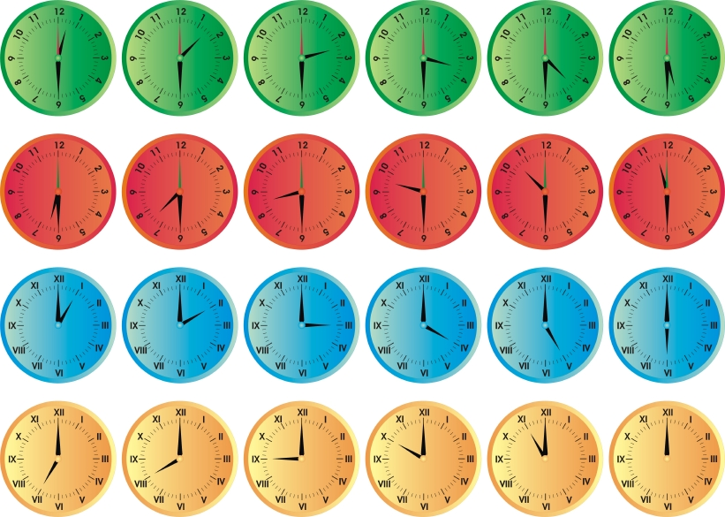  Remember, you can’t totally fool your body clock, so your day sleep is likely to be shorter, lighter and more fragmented than your night sleep. So, after a few nights you could be in ‘sleep debt’ and very tired – just when you have to drive home in the morning. If this happens, find an alternative to driving.  After your last night shift try to adjust your body clock to being awake in the daytime. Ways to do this are:  - Sleep for only two-three hours on the first morning after night shift and then get a good long sleep that night and subsequently; and  - Get plenty of exposure to daylight/sunlight on your days off. The shift back to a daytime body clock setting will therefore be quite rapid.  Permanent Night Shift  If you are a permanent night worker or are returning to night shift after your days off, use the tips above from ‘Slow Shift Rotation’. On your days off, try to remain as ‘nocturnal’ as possible. This can be difficult and not suit your family or social life, so try the following:  - Get up late in the morning (e.g. after midday) and go to bed late at night (e.g. after midnight);  - Avoid morning sunlight (stay indoors as much as possible or wear sunglasses); and  - Try to stay with your night shift meal schedule as much as possible.  3. Creating a Good Sleep Environment  A good sleep environment is one that is:  - quiet, without loud or sudden noises  - dark no matter what time of day/night  - warm or cool enough to help you sleep  - comfortable, in terms of the mattress*  - well ventilated  - free from interruptions  If noise is disturbing your sleep, you could consider:  - earplugs  - white noise, which comes from a noise-making  4. Creating Good Sleep Routines  Your body and mind can learn that it is time to relax and go to sleep. Establishing a regular pre-sleep routine can provide specific cues that indicate to your body and mind that it is time for bed and sleep. For example, consider a regular schedule of reading, listening to music, or using relaxation techniques before bed. Also, consider the timing of taking a warm bath, getting dressed for sleep, and actually getting into bed.  Consideration should also be given to establishing regular bedtime and wake- up schedules. For many, this is difficult or impossible; however, the internal body clock relies on consistent signals to keep it on time. Whenever possible, try to maintain consistent sleep and wake-up times on off-duty days and on duty days. Because the internal body clock seems to be especially effective as an alarm clock, maintaining a consistent wake-up time can be particularly beneficial.  5. Napping Strategies – Not to be used as a strategy whilst at work  Napping and sleeping are not the same thing. Sleeping is long and deep, while napping is brief and shallow. However naps can be a very effective means of managing alertness but there is an art to taking them. Several factors must be considered, including time of day, length of nap and individual differences in sleep patterns.  Time of day impacts napping in several ways. Our bodies continue to follow pre-programmed circadian rhythms regardless of how long we have gone without sleep. Thus, at some times of the day, it is very difficult to sleep, no matter how tired a person feels. Conversely, a nap taken when a person is more relaxed and ready for sleep will be deeper and more restorative.  One particularly interesting napping phenomenon is the impact of length of naps. It may surprise you to know that naps of 15 minutes’ duration can be just as restorative as those of a half-hour to an hour in length. Sleep physiologists have discovered that, because of the body’s 90- to 100-minute sleep cycles, short (15 to 20 minutes) or long (2 hours) naps are the most restorative.  mental tasks and motor skill coordination. It also increases capacity for muscular work, and it takes effect quickly – 15 to 45 minutes after ingestion. Yet caffeine is a drug that can remain in the body on average from 3 – 5 hours and sometimes up to 12 hours. It can increase restlessness, disrupt normal sleep architecture and cause gastrointestinal disturbances.  What is your caffeine intake like? The Caffeine Survey provides guidelines on how to work out you daily caffeine intake.  If you tend to over-use caffeine, the following guidelines will help you manage your intake:  - Use caffeine in moderation. This includes obvious sources such as coffee, tea, cola drinks and stimulants as well as painkillers, cold/allergy medicine and chocolate.  - Time your use of caffeine for when it is needed most, and avoid it for several hours prior to sleep.  - Replace caffeine with fruit, fruit juice or water.  - If you are currently a heavy caffeine user, don’t quit “cold turkey”, but cut back gradually over 1 to 2 weeks.  Nicotine  Nicotine, like caffeine, is a stimulant. Smoking before bed makes it more difficult to fall asleep. When smokers go to sleep, they experience withdrawal from nicotine, which also causes problems falling asleep or waking in the morning. Smokers may also experience more nightmares. Giving up smoking may cause more sleep problems at first, but the long-term effect on sleep and health is much better.  Nutrition  Eating the right foods – and avoiding the wrong ones – is even more important for people who work irregular schedules, because they must deal with the added stress of a constantly changing lifestyle and irregular eating patterns. Poor nutrition can not only deter alertness but also lead to gastrointestinal disorders, heartburn, ulcers, loss of appetite or weight gain and, potentially, cancer and cardiovascular disease.  In addition to the advice about managing your caffeine intake, there are a few simple rules for managing what you eat to help you cope with eating and shiftwork: |  | 2. Managing Your Work Time  There are three types of shift work:  - Fast shift rotations (with changes every few days or less);  - Slow shift rotations (changes fixed for more than a few days); and Permanent night shift.  - Permanent night shift.  Whichever shift you work, there are ways to help your body adjust. Here are some tips.  Fast Shift Rotations  Try to maintain a daytime setting for your body clock. Ways to do this can be:  - Spending time out in the daylight before and after your night shift;  - Avoiding a heavy meal during the night;  - Having a nap at home before your night shift (early afternoon would be best); and  - Having a 20-30 minute nap during your night shift if possible/appropriate (allow at least ten minutes to wake up properly before returning to work duties).  Slow Shift Rotations  Try to adjust your body clock as rapidly as possible to a setting for being awake at night by:  - Going to bed as soon as you get home from night shift. Avoid having your main sleep in the evening – your body temperature/alertness is up and sleep is more difficult  - Having an afternoon nap if you didn’t get enough sleep in the morning  - Avoiding a nap during the night shift, unless you are very sleepy. (If you do nap, keep it short – 20-30 minutes)  - Trying to avoid exposure to early morning daylight on the way home from work, as this can set your body clock to daytime setting, (try wearing sunglasses)  - Eating three regular meals, with ‘lunch’ during your night shift.  - machine such as a fan or generator  - rugs  - heavy curtains or drapes  - double-pane windows  - relaxing music or tapes  * Although there isn’t much published research on mattresses, mattress quality may affect how sleep feels to the sleeper. Discomfort can make falling asleep more difficult and lead to restless slumber. Mattresses may be made of inner springs, foam, fabric, water or air. They may be firmer or more responsive to your body. This, in turn, may affect body temperature and humidity, as well as comfort.  As well as the physical environment, a good sleep environment is also concerned with ensuring you recognise it as a place to sleep.  Just as the body and mind can learn that it is time to relax and go to sleep, if the bed or bedroom is associated with activities that are too engaging or negative, they can signal stress and wakefulness. Therefore, try to avoid using the bedroom for work, balancing the chequebook, watching television, or other activities that might be activating or stress inducing rather than relaxing. Use your bed only for sleep and this will strengthen the psychological association between bed and sleep.  Other things that you can do to this are:  - Only getting into bed when you’re tired. If you don’t fall asleep within 15 - 30 minutes, get out of bed. When you’re sleepy, go back to bed.  - While in bed, don’t dwell on not sleeping or your anxiety will increase. In addition, if looking at a bedroom clock makes you anxious about how much time you have before you must get up, move the clock out of sight. Do not engage in activities that cause anxiety and prevent you from sleeping.  - Protect your sleep time. Identify a specific sleep time(s) and protect it by minimising other distractions or responsibilities. At home, this takes planning, persistence, and understanding when trying to balance sleep requirements with family obligations and activities.  Another important factor to consider in napping is sleep inertia, the time it takes to return to full alertness after a nap. At certain times of the day, for example, a prolonged nap can actually be detrimental to performance because of long recovery time. Relatively brief naps, however, produce minimal sleep inertia, and the napper typically returns to full alertness within minutes. Awakening in the midst of deep stages of sleep also increases inertial. That is why 1-hour naps are less desirable than those of 20 minutes or 2 hours.  Early afternoon and the pre-dawn hours are particularly viable napping times because they are the times of lowest circadian alertness levels. In fact, sleepy drivers are particularly well advised to pull off the road and nap at these times, when single-vehicle accident rates are at their highest.  A Personal Napping Strategy  A personal napping strategy is an invaluable tool for achieving alertness when required and sleep when desired. To develop this strategy, first identify your ideal nap. What time does it take place? Where does it take place? How do you get ready for it? How long does it take you to fall asleep? How long do you nap? How do you feel when you wake up?  After you’ve identified your ideal napping habits, put them to work for you. Use your knowledge to develop effective pre-nap rituals, establish a conducive napping environment and develop a wake-up routine.  Once you’ve adapted to your ideal nap, break the routine. Try to nap at different times, in different places and for varying durations. The objective of a personal napping strategy is to be able to capitalise on any napping opportunity, even if it does not come at an ideal time or place or for an ideal duration.  6. Physiological Measures  Managing Caffeine  Caffeine, although present in coca cola and chocolate is mainly consumed in the form of coffee and strong tea. It can also be found in many over-the- counter medications, such as pills for headache and cold relief.  Caffeine is like Dr. Jekyll and Mr. Hyde. It is an effective, inexpensive and readily available stimulant that can improve alertness, reaction time, performance of  - When working through the night, avoid greasy, starchy or high-fat foods.  - Your body is not able to digest food properly in the middle of the night. Instead, eat light snacks such as clear soups, fruit or toast.  - Avoid a heavy meal just before bed. Your body won’t be able to digest it, and it will keep you awake, trying. However, if you are hungry do eat something as being hungry or thirsty can impede the onset of sleep  - Keep your main meals on a regular scheduled. Your body responds best when meals occur at regular intervals. Try to eat at least three meals per day, even if they are light.  - Eat a wide variety of foods, particularly fruits, vegetables, lean meats and low-fat dairy products.  - Remember that tomato juice, strongly flavoured seasonings, spicy foods, coffee and cola drinks are gastro-irritants.  - Avoid alcohol. Although many people think of alcohol as a sleep aid because of its sedating effect, it causes more sleep disruptions throughout the night. Consuming alcohol before bedtime usually helps people to relax and fall asleep, but can lead to a night of disturbed sleep.  Exercise  Exercise can be a boon for good sleep, especially when done regularly in the afternoon and not too close to bedtime. Research suggests that exercise can help deepen your sleep, which means that you spend more time in deeper stages of sleep and you wake feeling more refreshed. Also, people who exercise may take less time to fall asleep than people who don’t.  Traditionally, sleep experts have cautioned people to avoid strenuous exercise right before sleep and even up to three hours before bedtime. That’s because exercise has an alerting effect and raises you body temperature. This rise leads to a corresponding fall in temperature five to six hours later, which makes sleep easier then. That’s why late afternoon may be the perfect time for your exercise. If you’ve been exercising close to bedtime and having trouble falling or staying asleep, try to arrange your workout earlier in the day.

