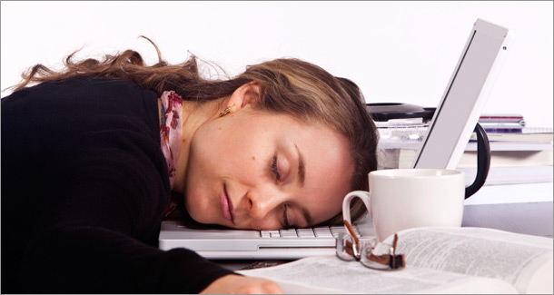

Identify a suitable sleep schedule  - If you work regular shifts, try going to bed at different times to find the optimum for maximum sleep e.g. soon after arriving back from work or stay up and sleep before the next shift  - Have a short sleep before your first night shift  - If coming off night shifts, have a short sleep and go to bed earlier that night  - Once you have identified a suitable sleep schedule, try to keep to it  Make the environment favourable for sleeping  - Sleep in your bedroom and avoid using it for other activities; e.g. watching TV, eating and working  - Use heavy curtains, blackout blinds or eye shades to darken the bedroom  - Disconnect the phone or use an answer machine and turn the ringer down  - Ask your family not to disturb you and keep the noise down when you are sleeping  - Discuss your work pattern with close neighbours and ask them to try and avoid noisy activities during your sleep time  - If it is too noisy to sleep consider using earplugs, white noise or background music to mask external noises  - Adjust the bedroom temperature to a comfortable level, cool conditions improve sleep  Diet  - Choose foods that are easy to digest; e.g. pasta, rice, bread, salad, fruit, vegetables and milk products  - Avoid fatty, spicy and/or heavy meals as these are more difficult to digest  - Avoid sugary foods; e.g. chocolate  - Fruit and vegetable are good snacks as their sugar is converted into energy relatively slowly and they also provide vitamins, minerals and fibre  - Drink plenty of fluid, as dehydration can reduce both mental and physical performance, but avoid drinking too much fluid before sleeping, as this may overload the bladder  Physical fitness and a healthier lifestyle  - Improve fitness spending 30 minutes a day on a physical activity including housework and walking  - Eat healthy meals on a regular basis  - Cut down or give up smoking  - Reduce your alcohol intake (14 units per week and no more than 3 units in any one day for women; 21 units per week and no more than 4 units in any one day for men)  Stimulants and Sedatives  - Only use caffeine occasionally and don’t rely on it to keep you awake  - Avoid the use of alcohol  - Regular use of sleeping pills and other sedatives is not recommended  - The use of new drugs that alter alertness is not advised unless under medical supervision |  | Family and Friends  - Talk to friends and family about your work. If they understand the problems you are facing it will be easier for them to be supportive and considerate  - Make your family and friends aware of your schedule so they can include you when planning social activities  - Make the most of your time off and plan meal times, weekends and evenings together  - Plan your domestic duties around your shift schedule and try to ensure that you do not complete them at the cost of rest/sleep  Techniques to promote sleep  - Go for a short walk, relax with a book, listen to music and/or take a hot bath before going to bed  - Avoid vigorous exercise before sleep as it is stimulating  - Avoid caffeine, ‘energy’ drinks and other stimulants a few hours before bedtime as they can stop you going to sleep  - Don’t go to bed feeling hungry: have a light meal or snack before sleeping but avoid fatty, spicy and/or heavy meals as these are more difficult to digest and can disturb sleep  - Avoid alcohol as it lowers the quality of sleep  Ways to improve your alertness at work  - Take moderate exercise before starting work which may increase your alertness during the shift  - Keep the light bright  - Take regular short breaks during the shift if possible  - Get up and walk around during breaks  - Plan to do more stimulating work at the times you feel most drowsy  - Keep in contact with co-workers, as this may help both you and them stay alert  - Try and take a 15 minute walk in daylight everyday  Driving to and from work  - Consider using public transport or taxis  - Exercise briefly before your journey  - Share driving if possible  - Drive carefully and defensively  - Try not to hurry  - Stop if you feel sleepy and take a short (15 minute), nap if it is safe to do so  - Make occasional use of caffeinated drink

