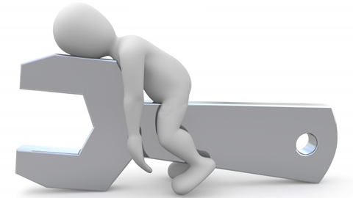

Signs of Fatigue  Physical signs  - Repeated yawning  - Rubbing eyes  - Staring blankly, eyes going in and out of focus  - Frequent/long blinks  - Difficulty keeping eyes open  - Head nodding  Negative mood  - Reduced tolerance for what is going on around us.  - Become irritable and are more easily frustrated.  - Lethargic and lacking in initiative and motivation.  - Reduced willingness to interact with others.  Reduced communication  - Reduced willingness and ability to communicate  - Less descriptive language  - May neglect to pass on important information to colleagues  Slips and /or lapses  - Slips – i.e. accidentally doing the wrong thing e.g. picking up the wrong tool  - Lapse – i.e. accidentally not doing the right thing e.g. forgetting to tighten a nut |  | Poor memory  - Impairs short-term memory so we forget what we have and have not done  - Cannot recall recent conversations or information read  Reduced attention  - Difficulty dividing our attention appropriately between multiple tasks  - Hard to plan for future actions  - Concentration lapses  - Easily distracted from the task in hand  - Become fixated on one particular task (‘narrowing of focus’/cognitive tunnelling’) so too much attention or insufficient attention is paid to peripheral events and auxiliary tasks  Impaired problem solving  - Disruption of problem solving processes  - Identification & evaluation of alternative courses of action  - Construction of mental images  - Integration of incoming information with existing knowledge  - Persevere with ineffective solutions  Increased risk taking  - Reduced ability to assess risks  - Increased willingness to take risks  - More likely to cut corners  - Accept lower standards in accuracy and performance

